

***Dissertation on***

**“SMART PARKING SYSTEM”**

*Submitted in partial fulfilment of the requirements for the award of degree of*

# Bachelor of Technology in

**Computer Science & Engineering UE18CS390A – Capstone Project Phase - 1**

***Submitted by:***

**R S CHAITRA SREE**

**PALLAVI A N**

**YUKTHI G L**

**ABHISHEK D**

**PES1201801628**

**PES1201801979**

**PES1201802033**

**PES1201802109**

*Under the guidance of*

**Prof. Sunitha R**

Professor

PES University

**January - May 2021**

**DEPARTMENT OF COMPUTER SCIENCE AND ENGINEERING**

FACULTY OF ENGINEERING

**PES UNIVERSITY**

(Established under Karnataka Act No. 16 of 2013) 100ft Ring Road, Bengaluru – 560 085, Karnataka, India

# PES UNIVERSITY

(Established under Karnataka Act No. 16 of 2013)

100ft Ring Road, Bengaluru – 560 085, Karnataka, India

**FACULTY OF ENGINEERING**

CERTIFICATE

*This is to certify that the dissertation entitled*

**‘Smart Parking System’**

*is a bonafide work carried out by*

**R S Chaitra Sree**

**Pallavi A N**

**Yukthi G L**

**Abhishek D**

**PES1201801628**

**PES1201801979**

**PES1201802033**

**PES1201802109**

in partial fulfilment for the completion of seventh semester Capstone Project Phase - 1 (UE18CS390A) in the Program of Study - Bachelor of Technology in Computer Science and Engineering under rules and regulations of PES University, Bengaluru during the period Jan. 2021 – May. 2021. It is certified that all corrections / suggestions indicated for internal assessment have been incorporated in the report. The dissertation has been approved as it

satisfies the 6th semester academic requirements in respect of project work.

Signature

Prof.Sunitha R

Designation

**Name of the Examiners**

Signature Dr. Shylaja S S

Chairperson

**External Viva**

Signature

Dr. B K Keshavan Dean of Faculty

**Signature with Date**



**1.** _

**2. _**

# DECLARATION

We hereby declare that the Capstone Project Phase - 1 entitled **“Smart Parking System”** has been carried out by us under the guidance of Prof.Sunitha R, Professor and submitted in partial fulfilment of the course requirements for the award of degree of **Bachelor of Technology** in **Computer Science and Engineering** of **PES University, Bengaluru** during the academic semester January – May 2021. The matter embodied in this report has not been submitted to any other university or institution for the award of any degree.

|  |  |  |
| --- | --- | --- |
| **PES1201801628** | **R S Chaitra Sree** | **<Signature>** |
| **PES1201801979** | **Pallavi A N** | **<Signature>** |
| **PES1201802033** | **Yukthi G L** | **<Signature>** |
| **PES1201802109** | **Abhishek D** | **<Signature>** |

# ACKNOWLEDGEMENT

I would like to express my gratitude to Prof. Sunitha R, Department of Computer Science and Engineering, PES University, for her continuous guidance, assistance, and encouragement throughout the development of this UE18CS390A - Capstone Project Phase – 1.

I am grateful to the project coordinators, Prof. Sunitha R, for organizing, managing, and helping with the entire process.

I take this opportunity to thank Dr. Shylaja S S, Chairperson, Department of Computer Science and Engineering, PES University, for all the knowledge and support I have received from the department. I would like to thank Dr. B.K. Keshavan, Dean of Faculty, PES University for his help.

I am deeply grateful to Dr. M. R. Doreswamy, Chancellor, PES University, Prof. Jawahar Doreswamy, Pro Chancellor – PES University, Dr. Suryaprasad J, Vice-Chancellor, PES University for providing to me various opportunities and enlightenment every step of the way. Finally, this project could not have been completed without the continual support and encouragement I have received from my family and friends.

# ABSTRACT

We present a more efficient method for Smart car parking system in the large scale parking

Slots based on IoT Domain. This system consists of an on-site deployment of an IoT module that is

Used to monitor and signalize the state of availability for each single parking slot.

Smart car parking system project primarily makes searching of parking systems more efficient and less time-consuming. This system is a combination of IoT and cloud computing technology, this system helps a user know the availability of parking slots on a real time basis. The main objective of the system is to reduce searching time, fuel consumption and carbon di oxide emission.

**TABLE OF CONTENT**

##### Chapter No. Title Page No.

##### INTRODUCTION 6

##### PROBLEM STATEMENT 7

##### LITERATURE REVIEW

* 1. IoT Based Sensor Enabled Smart Car Parking 9

##### Sustainable vehicle parking 12

* 1. Smart Parking System for commercial stretch 14

* 1. Smart parking system with automated payment system 17

1. DATA
   1. Overview 18
   2. Functions of Components 18
   3. Advantages 19
   4. Disadvantages 19

##### SYSTEM REQUIREMENTS SPECIFICATION 20

1. **SYSTEM DESIGN (detailed) 26**

##### IMPLEMENTATION AND PSEUDOCODE (if applicable) 28

1. **CONCLUSION OF CAPSTONE PROJECT PHASE-1 29**

##### PLAN OF WORK FOR CAPSTONE PROJECT PHASE-2

##### REFERENCE/ BIBLIOGRAPHY

## CHAPTER 1

**INTRODUCTION**

Parking space has become very limited all over the world as there is an increase in number of vehicles drivers should keep searching for parking spots. This is the major problem in urban areas as there is higher number of vehicles than the availability of parking spots. These problems occur due to lack of improved technologies today.

Searching for a parking spot is risky and frustrating activity for many of the people in urban cities. Thus, all the big companies or even the small one should provide the sufficient and convenient parking spot for the visitors.

Currently, the condition is getting worse in finding the availability of parking slots, so it’s very important to have an effective solution of implementing a technology to know the empty slots. Our System is an Arduino microcontroller based project, in this proposed system availability of parking spots is obtained through sensors. This system is user-friendly and helps the drivers to easily recognize the number of empty slots and save their time in searching the empty slot. In Driver’s point of view, this system helps to reduce the consumption of time and also the travel time would be reduced because of the information provided by this system.

**CHAPTER 2**

**PROBLEM STATEMENT**

A Smart Parking is a parking management system where users can find their parking slots in a more efficient manner. As we all know about the parking problems we face in our day-to-day life , with increasing population and increasing vehicles it has almost been impossible to find parking slots.

With increasing vehicles there is increase of environment hazards like global warming, air pollution etc. There were few systems introduced to control environment hazards such as carpooling where people who stay nearby could travel together so that number of cars travelling could be reduced, in few states they also made a rule were based on their car number they were allocated certain days of travel , for eg: odd numbered cars could go on mon,tues,wed.

Few people did follow this method in initial days. But slowly this technique started reducing.

According to study people spend most of their time on road by looking for a parking space, this increases emission of gases resulting to global warming. Therefore implementing a Smart Parking system would be useful to environment and also could save a lot of time.

In our system we are restricting this to indoor parking (such as malls,colleges,supermarket etc) . There would be Sensors and LED placed on-site, as soon as vehicle approaches the sensors detects the vehicle and LED glows indicating the slot is already occupied. There would be a LCD displaying no slots left in case all the slots in the building is completely occupied so that no user would drive all through the parking space in search of free parking slot.

**CHAPTER 3**

**LITERATURE SURVEY**

* 1. IoT Based Sensor Enabled Smart Car Parking for Advanced Driver Assistance System

In this paper Ultrasonic sensor is used to detect the availability of the parking slot. Each sensor is attached with WiFi chip, and Raspberry pi board updates the cloud by using the MQQT protocol. Implementation cost is too high as every sensing node have its own WiFi chip. Here the waiting time is detected based on the variable parameters that are the time of delay, day of week ,weather humidity .

The algorithm used for prediction is Support vector regression and the neural network. This car parking system shows the four parking states, those are available parking space,Reserved parking space ,presence parking space load/unload parking space. Geomagnetic sensors are used to detect the presence of the car.

The combination of the Geomagnetic and the ultrasonic sensors is used to detect the accurate and the reliable service in the vehicle parking slot.

Methdology :

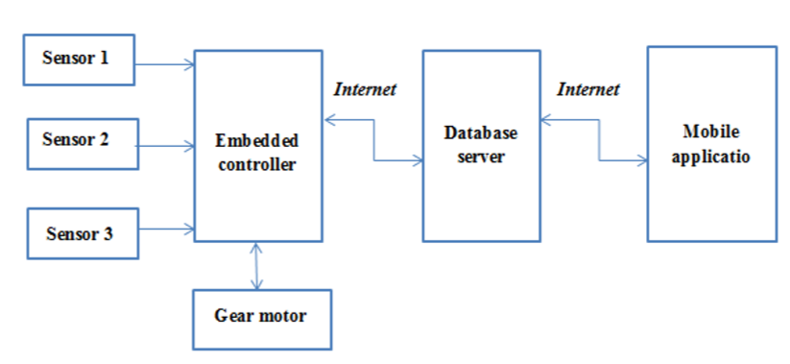

**Embedded controller**: The input from the parking slot is given by the embedded system. If there is any changes in the inputs this system will updates the information which is collected from the database server.

**Database server:** Information shows the availability of the parking slot and the time duration of the parking will be maintained in the server. Servers will be updated in the 2 terminals, One from the sensors and embedded system another from the User.

**Mobile application**: It shows the User to check the available parking space and to book the parking space based on the adhar card number and the authentication should be unique.

**Advantages:**

*The Sensors is not dependent upon the color or the transparency of the vehicle.

*IR Sensors are used in critical situations like dirt and the dust.

*There will be the accurate detection even for the very small objects.

**System flow Diagram :**

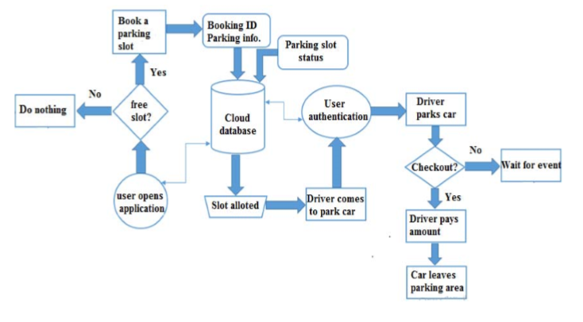

**Step1:** The user will check the mobile application for the parking slot ,and it will display the status of the parking area which is updated from the embedded system.

**Step2:** The information is updated in the cloud, based on the user booked slot and the user ID in the given date and time.

**Step3:** If the slot is locked from the others then another slot will given to the Present User.

**Step 4:** When the Driver reaches the parking area to park the vehicle ,both the vechile ID and the driver is authenticated by using the unique ID

**Step5:** Thus the algorithm validates the parking time and the charges based upon the presence of the car at the parking slot. When driver selects checkout button, there will be temporary displayed in the user application.

**Step6:** Once the car leaves the parking area the user will be charged for the calculated amount of time and the status of area is updated as free in server database.

* 1. A Sustainable Vehicle Parking using IoT

**Existing System**:-In the Present system parking process is done in a larger manner where a Person is employed to generate parking tokens, to check the availability of the parking slots, to help getting the vehicle parked in parking slots and also to collect the parking fee.

Some peoples may have to wait for a long time and in the weekends it will be a time taking process to park a car. This creates a non-user friendly environment.

**Proposed System:-**The Users can check the number of occupied slots and can book the parking slots in advance to park their vehicles. In this system, User vehicle information are stored in the server.

When the vehicle enters the parking area the camera detects the number plate and verifies it with the database to check whether they have booked advance parking slots. Once the vehicle passes through the gate in-time is noted and 15 minutes before the slot booking time gets over the system sends a notification to the user’s mobile to help the user extend the parking slot booking time.

**Proposed System Architecture:**

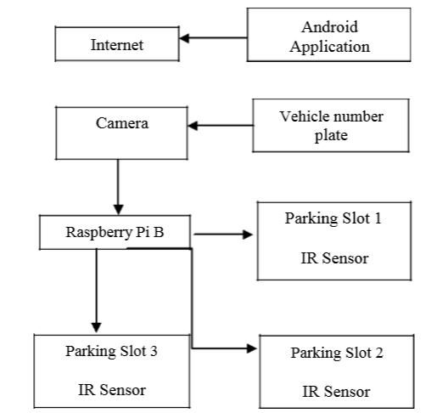

In this system cameras are used to capture the number plate. When the user books a slot using the android application the server blocks a parking slot for the user. Then the camera captures the image of the car and also the number plate is verified.

Car Parking system can be improved in future days by implementing payment through online basis and by increasing the access of the application for the users and the parking managements.

### Smart Parking System For Commercial Stretch

### The people living in smart city faces the main Problem is parking with the number of vehicles increasing exponentially and scarcity of facility or area for parking and traffic problem so there is a demand for smart parking system which solves the problem.

### The normal method of finding a area for parking is where driver would come down from car and go around in search of vacant area for parking the vehicle, this causes traffic to vehicle behind.

### Smart parking is the solution that helps to overcome the problems caused by normal parking. This paper proposes a system based on IoT technology which minimizes the efforts of the people in finding the parking area by finding the free slots in parking area and making the record of vehicles parked.

### 

### The smart parking system helps a user to book a parking slot before entering into the parking and notification(detail) about the slot booked is sent to the user and the system has a automated payment system where the parking amount is directly deducted from the user account.

### 

### Thus smart parking provides more number of vehicles to park, user-friendly parking, lesser power consumption, helps in more efficient use of space and also gives solutions to various problems which might occur during parking the vehicle.

### 

### A.Khanna and R. Anand have proposed that user may book the parking slot on before reaching into the parking area and then park their vehicle. And without booking also they can park at parking area Here they are providing the facility for both the users to park their car on spot and pre-registered users.

### 

### They made the express entry and express exit which is a good option for the user to save their time and made easier parking. If new user enters unknowingly into express entry and PIR sensors sense whether the car present in the parking slot and sends the info to the database.

### When a user registered, all the details of the user are stored in database through the cloud storage. They are using IP cameras for scan number plate of the vehicles of the users and when the user enters, the details about that vehicle gets from database to check whether a valid user then giving parking slot details for him to park through message or notification through mobile.

### The sensors in parking area are connected to Raspberry Pi where Raspberry pi is connected to database on one side and sensors on the other side. They built using Python platform which is a user friendly.

### When the vehicle enters the parking area, the PIR sensors senses and the timer starts. When the vehicle leaves the parking area the PIR sensors again senses and the timer stops which is connected to the raspberry pi and the server connects to algorithm.(pricing) and display the price.

### The paper gives the following features:

### **Minimum distance to the destination/parking slot**: Guide the short path so indirectly minimize pollution and also reduces the use of fuel.

### **More efficient use of parking space**: For different types of vehicles different slot given .

### **Efficient allocation with respect to time**: If there is any slot allocated for pre-registered user, that slot given to new comer in case the register user comes late assuming buffer time of 15-30 min

### **Fuel saving**: Fast parking consumes less fuel.

### If new user enters through express entry The IP camera sensors which are placed at the entrance of the parking area detect the number plate and extract the details of the user in the database. When the details in the database doesn’t match the gate won’t open indicate not a valid user.

### If a person parks in the wrong area/slot When the user unknowingly parks in the wrong slot due to technical or data connectivity issues, PIR sensors which are connected in the parking space triggered and sends a notification to the central coordinating system and then it will look into the issue correct it.

### Smart parking system with automated payment system

### This paper proposes a smart parking system based on the IoT which uses cloud application and web technology. The application allows users to book a slot in the parking area. Firstly The user has to create and register through the smart parking application which is a web application. The details are stored in the database in the server system. After the registration process, the user may login to his application to check or see the available parking slots and also user can do parking slot reservation. Each parking slot occupied by light dependent resistor (LDR) sensor. LDR sensor is used for detecting vehicle mean whether slot is occupied by vehicle or not.

### If a slot is available then user can book it and details about the slot will sent to the user mobile. A atomic(unique) slot is booked for each user. Multiple users won’t be able to book the same slot Each time vehicle is detected the data is updated. They used Radio frequency identification (RFID) tags for detecting car when enters the parking space timer starts to record the time of parking.

### The following algorithm describes the working of the system:

### Step1: If user is new, then register to the smart parking system application else go to Step 2.

### Step2: Login to the smart parking system application.

### Step3: Send the request for parking area to book a slot.

### Step4: The request is sent through the network to cloud.

### Step5: Continuously update the parking slots are which are empty or not.

### Step6: If a slot is available user can book slot and details about a slot will be sent to users mobile via application.

### Step7: Run the timer till a vehicle leaves slot or parking area

### Step 8: If vehicle is not parked, timer will stops price will be calculated.

### Step 9: Deduct the calculated amount from users account and send sms about payment

**CHAPTER 4**

**DATA**

### Overview

### The proposed system is Smart Car Parking System using IoT. This system is used to find the availability of parking spots using IR sensors, LCD display, LEDs to know whether parking space is empty or filled. This developed project is user-friendly and time consumption system.

### Functions of the components

|  |  |  |
| --- | --- | --- |
| Component | Diagram | Function |
| Arduino Uno |  | Communication and programming of the router and also the sensor level component |
| LED |  | Display the state of the car parking |
| Infrared sensor |  | Detection of the car during the entry and exit that is occupied or empty |
| LCD Display |  | Display the number of spots available and empty in the parking area |

### Advantage

### Makes human’s life much easier.

### Decrease in the fuel consumption and time to search a space

### Space Constraint

### Disadvantages

### It can to detect only for large vehicles.

### There should be continuous power supply.

### There may be a breakage of sensors due to unavoidable circumstances.

### Requires high maintenance and also each sensor should work properly to give a good efficiency in working of this system

**CHAPTER 5**

**PROJECT REQUIREMENTS SPECIFICATION**

|  |  |  |  |
| --- | --- | --- | --- |
| **PROJECT REQUIREMENTS SPECIFICATION**  **SMART PARKING SYSTEM**  **UE18CS390A – Capstone Project Phase – 1**  ***Submitted by:***   |  |  | | --- | --- | | **Pallavi A N**  **R S Chaitra sree**  **Abhishek D**  **Yukthi G L** | **PES1201801979**  **PES1201801628**  **PES1201802109**  **PES1201802033** |   Under the guidance of   |  | | --- | | **Prof. Sunitha R**  Professor  PES University |   **January-May 2021**  **DEPARTMENT OF COMPUTER SCIENCE AND ENGINEERING**  FACULTY OF ENGINEERING  **PES UNIVERSITY**  (Established under Karnataka Act No. 16 of 2013)  100ft Ring Road, Bengaluru – 560 085, Karnataka, India |

TABLE OF CONTENTS

|  |  |
| --- | --- |
| 1. Introduction | 22 |
| 1.1 Project Scope | 22 |
| 1. Product Perspective |  |
| 2.1 Product Features | 23 |
| 2.2 Operating Environment | 23 |
| 2.3 General Constraints, Assumptions and Dependencies | 23 |
| 2.4 Risks | 23 |
| 1. Functional Requirements | 23 |
| 1. External Interface Requirements |  |
| 4.1 User Interfaces | 23 |
| 4.2 Hardware Requirements | 24 |
| 4.3 Software Requirements | 24 |
| 4.4 Communication Interfaces | 24 |
| 1. Non-Functional Requirements |  |
| 5.1 Performance Requirements  5.2 Safety Requirements | 24  24 |
|  |  |
| Appendix A: Definitions, Acronyms and Abbreviations | 25 |
|  |  |

# Introduction

# In our day-to-day life we would have come across many problems during our travel. As we are familiar this problems are caused due to traffic and one of the reason behind this traffic would be parking space. We spend a lot of time and fuel in searching a parking space, and also as we drive we tend to slow down our vehicles whenever we find a free parking slot this may lead to accidents. In order to solve this problems we need a proper smart parking management system where it can lead the drivers to their appropriate parking slots (or) gives an idea about free parking slot nearby.

# In this document we would be sharing an idea about how we can implement a smart parking system inside campus, hospitals, malls etc. This document would contain all the details about the product, product functionality product features and how does it work in real world. Final product would be a working model.

# Project Scope

# Our main objective is to make parking more efficient and less time consuming. In our system we would be restricting our parking solution to indoor parking such as hospitals, malls, campus etc. We come around few benefits of our projects such as enhanced user experience, saves user time, less fuel wastage and much more. We also have few limitations of our system this system requires regular maintenance, there might be breakdown in system, cost of construction would be high.

# Product Perspective

# Product Features

The main feature about this product is that it indicates the presence of car and updates the number of available slots in LCD. It has IR Sensor which helps in detecting the presence of car feature. The number of available slots is updated based on the LED lights when the car gets parked The LED starts glowing indicating the car is parked in case of car parked the

Number of available slots reducing if case of free it increases.

# Operating Environment

* OS-windows/mac OS/Linux with Arduino IDE installed and supported.
* Sensors would run with continuous power supply.

# General Constraints, Assumptions and Dependencies

* The system in which the model is developed should have Arduino IDE installed.
* We assume there would continuous power supply.
* The system won’t work if there is no power supply.

# Risks

* There can be breakdown of sensors.
* Misusage of the system (some object kept on sensor instead of vehicle).
* As there would continuous power supply there will be chances of short-circuit.

# Functional Requirements

# REQ_1: Uninterrupted power supply.

# REQ_2: Sensors should be placed in safe place so that there will be no breakdown of sensors.

# REQ_3: Immediate update in LCD when car leaves or gets parked.

# REQ_4: Proper functionality of sensors

# External Interface Requirements

# User Interfaces

# As it is a hardware implementation the user interface will just be the LCD display which displays the number of available slots.

# Hardware Requirements

* Arduino UNO
* IR sensor
* LCD
* Jumper wires
* LED

# Software Requirements

* Arduino UNO
* SQL database

# Communication Interfaces

The communication interface is local area network through Ethernet.

# Non-Functional Requirements

# Performance Requirement

# 1. We will try to get a min of 80% accuracy

# 2. Sensors give long durability

# Safety Requirements

# Sensors are not broken

# There is no short-circuit during constant power supply

# Appendix A: Definitions, Acronyms and Abbreviations

|  |  |
| --- | --- |
| IOT | Internet of things |
| LED | Light emitting Diode |
| LCD | Liquid Crystal display |
| IR | Infra red |
| OS | Operating system |
| Arduino IDE | Software for arduino programming |

**CHAPTER 7**

**SYSTEM DESIGN**

Block Diagram:

Infrared Sensor

Arduino

Microcontroller

LCD display

LED

Cloud

Smart Car Parking system is an efficient and flexible technology. This system is user-friendly as it makes it easier to find the availability and empty parking slots for the driver’s vehicle to park. The project consists of Arduino which acts as microcontroller, Infrared proximity sensors, LCD display, LEDs and the cloud. It works only with the power supply. Infrared sensor emits the radiation and detects whether the car is present in the parking space or not. Infrared sensor sends the signal after detecting the car. Arduino fetches the data from the cloud and sends back the signal to LED to glow in the presence or absence of car in the parking space. And also it sends the data to LCD display. LCD display is a visual display which does not emit the radiation directly instead it shows the number of available and occupied count of vehicles in the parking area.

CIRCUIT DIAGRAM:

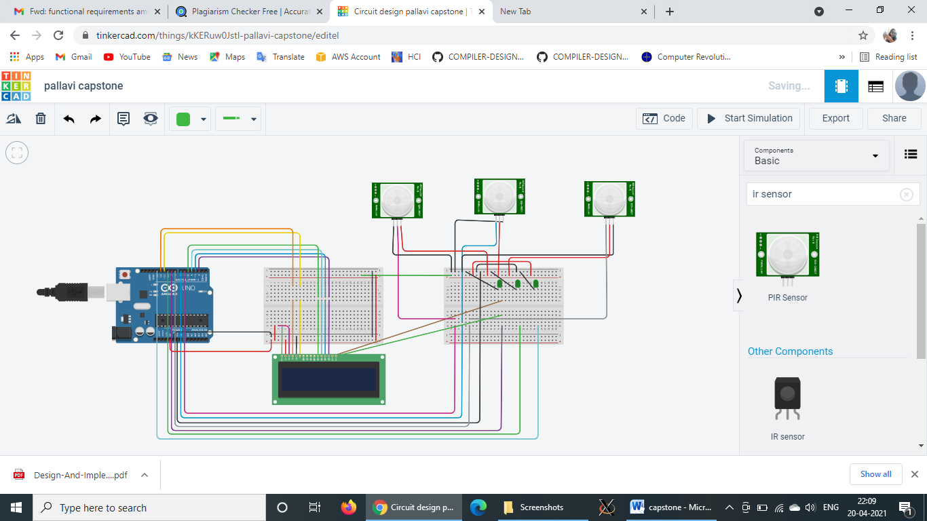

**CHAPTER 8**

**IMPLEMENTATION AND PSEUDOCODE**

**SOURCE CODE:**

#include<stdio.h>

#include<stdlib.h>

int IRSensor = 2;

int LED = 13;

void setup()

{

pinMode (IRSensor, INPUT); // sensor pin INPUT

pinMode (LED, OUTPUT); // Led pin OUTPUT

}

void loop()

{

int statusSensor = digitalRead (IRSensor);

if (statusSensor == 1)

{

digitalWrite(LED, LOW);

}

else

{

digitalWrite(LED, HIGH); // LED High

}

}

**IMPLEMENTATION:** We are using arduino UNO as our coding platform. IR Sensor are used to detect the presence of car as the above code is applicable to only one slot IR Sensor would be connected to Arduino and LED will directly be attached to Arduino so whenever it detects the presence of vehicle the LED starts glowing.

**CHAPTER 9**

**CONCLUSION OF CAPSTONE PROJECT PHASE-1**

As there is increase in vehicles there will be increase in air pollution which leads to global warming. One of the reasons for this is parking system as we have discussed earlier how current parking system effects the environment. Our main objective was to give users a more efficient and user-friendly way of parking their vehicle which would be less time consuming.

We have come up with an idea of how we can implement a more efficient indoor parking system.

This technology is very simple to use and it doesn’t require much of user interaction.

**CHAPTER 10**

**PLAN OF WORK FOR CAPSTONE PROJECT PHASE-2**

1. We would be implementing LCD display where it should automatically update the number of available slots.
2. Our current system is only for parking of vehicle we would be increasing the number of slots

**REFERENCE / BIBLIOGRAPHY**

[1] Smart Parking System For Commercial Stretch in Cities

By Dharmini Kanteti, D V S Srikar and T K Ramesh

Published in: [2017 International Conference on Communication and Signal Processing (ICCSP)](https://ieeexplore.ieee.org/xpl/conhome/8269242/proceeding)

Date of Conference: 6-8 April 2017

INSPEC Accession Number: 17562445

<https://ieeexplore.ieee.org/document/8286588>

[2] A Smart Parking System Using Internet of Things with Automated Payment System for Smart Cities

By Likith Prasanna ; Nagarjuna ; Karthik ; Kallinatha ; Nandakumara

Published in: [2018 3rd IEEE International Conference on Recent Trends in Electronics, Information & Communication Technology (RTEICT)](https://ieeexplore.ieee.org/xpl/conhome/8977133/proceeding)

Date of Conference: 18-19 may 2018

INSPEC Accession Number: 19411094

<https://ieeexplore.ieee.org/document/9012565>

[3] IoT  based sensor enabled smart car parking for advanced driver assistance system

By Mahendra ; Savita Sonoli ; Nagaraj Bhat ; raju ; T Raghu

Published in: [2017 2nd IEEE International Conference on Recent Trends in Electronics, Information & Communication Technology (RTEICT)](https://ieeexplore.ieee.org/xpl/conhome/8241508/proceeding)

Date of Conference: 19-20 May 2017

INSPEC Accession Number: 17504158

<https://ieeexplore.ieee.org/document/8256988>

[4] A Sustainable vehicle parking using IoT

By T Anandhi ; Kumaar V.S. Kishore ; Ganesh S.Maha ; R.M Gomathi

Published in: [2019 3rd International Conference on Trends in Electronics and Informatics (ICOEI)](https://ieeexplore.ieee.org/xpl/conhome/8851338/proceeding)

Date of  Conference: 13-25 April 2019

INSPEC Accession Number: 19875643

<https://ieeexplore.ieee.org/document/8862641>